Educator’s Guide: Lesson Plans and Activities for the North Carolina River Basin Materials

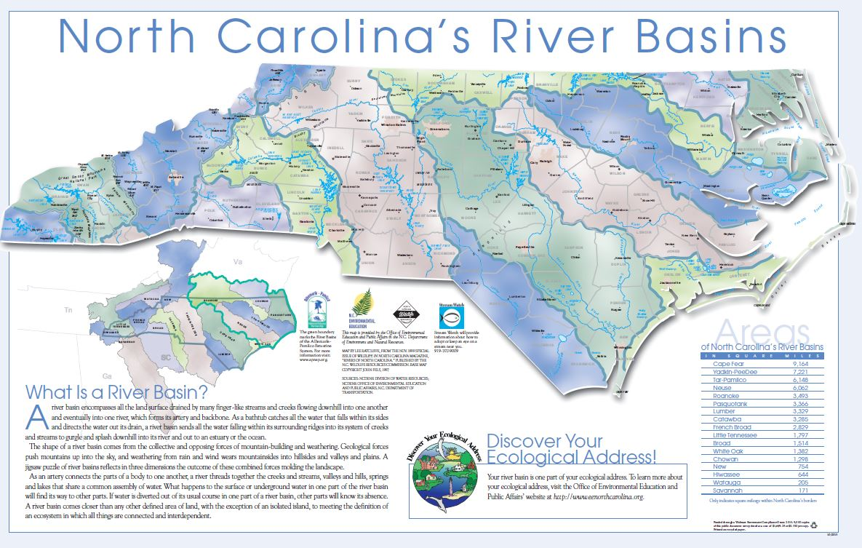

North Carolina Office of Environmental Education and Public Affairs
1601 Mail Service Center, Raleigh, NC 27699-1601 | www.eenorthcarolina.org
Updated October 2015

Background:
The River Basin Education Program for the N.C. Office of Environmental Education and Public Affairs has been providing quality publications on the river basins of N.C. since the 1990s. These publications are free and have been produced and disseminated across the state through state and grant funding. This document is a compilation of select lessons and activities from educators that have used these publications. This guide can be used in conjunction with River Basin Program materials. Feel free to download these materials or order hard copies free of charge: http://www.eenorthcarolina.org/riverbasins.html

Correlation to the N.C. Essential Standards:
Originally intended for an adult audience, educators have reported using these materials for grade levels 4 and up. We have found that lessons designed around the publications correlate best to the following N.C. Essential Standards:

– 8th grade Science 8.E.1.1: Local river basins and water availability

– 8th grade Science 8.E.1.3: Predict the safety and potability of water supplies in N.C. based on physical and biological factors

– 8th grade Science 8.E.1.4: Conclude that good health of humans requires: monitoring the hydrosphere, water quality standards, methods of water treatment, maintaining safe water quality, and stewardship

– 9th grade EEn.2.4.2: Evaluate human influences on water quality in N.C.’s river basins, wetlands, and tidal environments

Using this guide:
These lessons and activities were submitted by formal and non-formal educators for various subjects and age groups. Please feel free to use these ideas and adapt them to your curriculum. Education is improved through collaboration and sharing, and it is probable that many of the ideas found here have already been built upon such a model. However, we do ask you to please give credit where appropriate if reproducing these ideas in any way.

For ease of use, lessons have been organized into three sections: 8th Grade Science, 9th Grade Earth/Environmental Science, and Various Grade Levels. But you may find many ideas that you can adapt to your subject/grade level throughout the document. Some are cut and pasted directly into the document while others are linked to our website.

8th Grade Science

- 8.E.1.1: Local river basins and water availability

- 8.E.1.3: Predict the safety and potability of water supplies in N.C. based on physical and biological factors

- 8.E.1.4: Conclude that good health of humans requires: monitoring the hydrosphere, water quality standards, methods of water treatment, maintaining safe water quality, and stewardship

Lesson plan
River Basins, Estuaries, and Ecosystems of North Carolina, In-class project by Diane Jackson, 8th Grade Science Teacher

Objectives
*To explain the structure of the hydrosphere including: Local river basins and local water availability.
*To evaluate the estuaries and river basins of North Carolina as they exemplify the fact that they are reservoirs of nutrients, minerals, and life forms.
*To evaluate the value and sustainability of North Carolina’s wetland ecosystems.
*To illustrate how terrestrial and aquatic food webs are interconnected.
*To describe how humans are affecting water quality.

Activities
Use the Discover North Carolina’s River Basins Booklet to complete the following activities:
- Discuss in writing four reasons environmental education is important.
- Create a cartoon that illustrates the reasons environmental education is important. Color the cartoon.
- Use a graphic organizer or thinking map to illustrate what issues brought the value of rivers to the public’s view and the results of this awareness (what happened as a result of these two issues)?
- Identify and explain four reasons why understanding rivers and river basins are important. Use a thinking map or graphic organizer of your choice to illustrate this.
- Use a sheet of paper to create a flip chart in which you define fully and illustrate the following terms: river basin, estuary, watersheds, groundwater, and ecosystem.
- Draw, color and label the water cycle. What are the various places in which precipitation can fall? Where are the places it can end up before it evaporates back into the atmosphere?
- Create a flash card that illustrates what a river is and why rivers are important.
- Make a concept web that illustrates the following:
  - *What things positively affect the health and water quality of a river? How do they do this? What are the effects of this?
  - *What things negatively affect the health and quality of a river? How do they do this? What are the effects of this?
- Decline in water quality led to government involvement. Discuss some of the outcomes of this. What did North Carolina do in response to this? Write in paragraph form.
- Draw a vegetative/riparian buffer and a non-vegetative buffer. Below the picture, explain how each affects runoff into the river and the plants and animals living in the river.
- Identify non-point source and point source (define, tree map to classify the two types of pollution).
- What can you do to protect your water basins? Create a pamphlet that you could pass out that would encourage others to help protect these valuable areas.
- North Carolina has 17 river basins. Draw North Carolina and color each of its river basins a different color. Locate your river basin and use a Sharpie to outline it in black.

Use the Our Living Estuaries packet to complete the following activities.
- Read the “Introduction to Estuaries” and label the factors upstream that can affect the estuary.
- Complete the “How Are You Connected to the Estuary” activity. When you have finished, color in blue the river basin from which we get our water supply.
- Read the “Estuaries are Habitat” article. Draw, color, and label an estuary which includes all five of the habitats described in the article. Below the picture of the estuary, draw the plants and animals that might be found in the various five habitats. Use a colored pencil or pen to connect each plant or animal to each habitat in which they might be found.
- Read the “Food Chains” activity sheet. Google search the plants and animals listed that can be found in estuaries. When you are done, draw as many food chains as you can on a sheet of paper. When you’ve finished, place the members of your food chain in the appropriate level of the circular graphic organizer provided.
Ex: zooplankton -hard clam common sea star
- Use the directions and paper provided to create an origami sea turtle.

Use the “Yadkin-Pee Dee River Basin” brochure to complete the following:
- Complete the Get to Know Your River Basin activity.
- Use a piece of construction paper to make a folder for your activities. Be sure to illustrate & color it.

Lesson plan
River Basin Presentation, Cecelia Leonard, Guildford County Schools

Activity: As a member of a committee that manages a particular water basin, you are to develop a presentation to a group of investors. The investors are searching for an area in North Carolina to create an outdoor camp for young people in middle and high school. This camp is to educate the young with knowledge of plant and animal life while enjoying outdoor activities like camping, rafting, swimming, hiking, etc. Since this endeavor is funded by the National Science Foundation, the participants will have to show gained knowledge in animal habitats, environmental conservation, and effects of urban growth and pollution on the river basin. Obtaining the contract for this camp is very important for your area. It will mean government money for future projects and a certain amount of stability in land use. This would also mean a growth in jobs in your area.

Your presentation is to introduce the investors to your river basin and to show why it would be the most attractive place for the camp. Now, go for it! Win that contract!

Directions for Power Point Project for River Basins:
- One group member should open Internet Explorer and go to http://www.eenorthcarolina.org/riverbasins-interactive.html
- One group member should open Power Point to begin the presentation.
- Choose blank layout for the 1st card.
- For you first slide, go to Textbox at bottom. Title should be about 36 font (name of your river basin). Members of your committee should also be listed on this slide in smaller font. Be sure to center title.
- Add pictures and script to at least 5 other slides (see Summary of Slides for guidelines).
- Last slide should have your summary points with your internet source
http://www.eenorthcarolina.org/riverbasins-interactive.html
- Save your work.

Summary of Slides:
- Title of river basin and committee members
- Location of river basin, main tributaries
- Animal Life
- Plant life
- Human population, large cities
- Pollution concerns- What is being done for conservation?
- Summary of positive features
- Web-site used for research (small font)

Lesson plan
River Basin Questions, Maryann Hodges, 8th Grade Science Teacher
This first set of questions is used in conjunction with the Discover North Carolina’s River Basins booklet:
1. What is a river basin?
2. What determines the health of the aquatic ecosystem?
3. How many river basins in N.C.?
4. What river basin do you live in?
5. How big is our river basin?
6. Draw and label the parts of the water cycle.
7. What are the nine components of your ecological address?
8. How is pollution classified?
9. What is a vegetative buffer?
10. Name four programs that are making a difference in N.C.
11. Why are some of the river basin boundaries different now?
12. What can you do to help maintain healthy water?
13. What “crises” made us take a closer look at N.C. rivers?
14. What is carried in water?
15. What is the difference between wetland and groundwater?
16. How can streams be physically manipulated?
17. What led to the government getting involved in the treatment of water?
18. Using the scale map on page 12 estimate the length of N.C. at its longest point.

These questions are used with the Pasquotank brochure:
1. What percent of the water is contained in the Pasquotank river basin?
2. What characteristics are unique to the Pasquotank river basin?
3. What are the “lesser” treasures of this area?
4. What president drained the dismal swamp?
5. The dismal swamp started out as 2,000 square miles how much land has been lost over the years?
6. What was the foundation of the Atlantic Inter-coastal Waterway?
7. What two turtle species are listed as threaten?
8. What is the primary water quality issue in the basin habitat?
9. What water issue comes with the development of beach communities?
10. Compare the Pasquotank to the French Board (I used these since that is the area we will visit with the students)

Lesson plan

River Basin Google Presentation, Submitted by Sam Sirois, Adapted from Online Materials

Students work in teams of 4 to research a particular river basin of their choosing from N.C. They look through the brochures to make their decision. As a team they create a Google presentation. Each student selects their area of focus for their river basin:
1) Counties & rivers
2) Man's impact
3) Flora & fauna
4) Headwaters, delta/mouth & landforms
The students use the brochure about their river basin and the internet to create between 5-10 slides about their focus area. As a group they teach the rest of the class about their river basin using their Google presentation. We take 5 class periods to do this as I am also teaching them how to use Google presentation and how to animate slides. I adapted this lesson from projects I found other teachers using online.

Field Trip

Water Quality Education, Airlie Gardens, New Hanover County

Airlie Gardens (part of New Hanover County Parks, Gardens & Senior Resource Center Department) developed curricula for 8th graders studying water quality. The curriculum includes pre- and post-visit activities, a document specific to Airlie’s aquatic resources, and more information about the Cape Fear River Basin. One of the eight stations described in their on-site field trip includes a discussion and study of the N.C. River Basins Map. Students are introduced to Cape Fear River Basin, the largest of 17 basins in the state. Students identify municipalities and land use in the river basin (i.e. agriculture) and discuss how those human developments impact water quality across the river basin. One of the post activities includes stakeholder discussion cards to be used for a mock community forum on water quality impacts across the basin.

Activity

River Basin Riddler, Office of Environmental Education and Public Affairs

This activity includes teacher instructions, a vocabulary list, riddle questions and clues, riddle cards for the students, and a blank map for filling in river basins and other important features. It utilizes the river basins map and the accompanying riddler cards. This can be found on our website here: http://web.eenorthcarolina.org/net/content/go.aspx?s=105459.0.108.37430

9th Grade Earth/Environmental Science

– EEn.2.4.2: Evaluate human influences on water quality in N.C.’s river basins, wetlands, and tidal environments

Lesson plan

River Basin Presentation and Local Water Supply Planning, Kerry Piper, Earth & Environmental Science, Apex High School

EEN 2.3.2b NC River Systems
Course: Earth/Environmental Science
Objective: 2.3.2b Explain river systems including N.C. river basins, aquifers, and watersheds.
Essential Questions: How are North Carolina river basins different? Why is it important to protect them?

Materials needed:
- Exploring North Carolina Set 2: Basin Basics (DVD)
- Copies of Basin Basics viewing guide
- N.C. River Basins Map
- Set of N.C. River Basins brochures

Video (~25min)
- Show “Exploring North Carolina: Basin Basics” for an overview of N.C. River Basins. This is season 4, episode #408.
  - DVDs were provided free to all N.C. schools. Video is also available online for download but can be slow on school connections.
- Each season has its own student guide, teacher guide and related activity, created by the NC Museum of Natural Sciences. Have students complete the student guide.

Activity (~55min)
- Explain that students will be researching the N.C. river basins in pairs and then sharing their information with the rest of the class.
- Each pair will read the brochure about one of the 17 river basins in N.C.
  - Make sure at least one pair has the river basin for your area!
- Students will then answer the following questions projected onto the screen:
  - What is the name of your river basin?
  - Where is the river basin?
  - How many miles of streams and rivers are included in the basin?
  - How many people live in the basin?
  - Describe the river basin (at least 5 more sentences)
  - Describe an environmental issue in the basin and what is being done about it (at least 5 sentences)
- Students will then make a brief presentation to the rest of the class regarding their river basin.
  - Students should point to their river basin on the N.C. River Basins map to give other students in class an idea of where the basin is located.

2.4.1c Local Water Supply Planning
(http://www.ncwater.org/) (http://www.ncwater.org/?page=128)

2.4.1c Evaluate the effects of population growth on potable water resources. Infer future effects.
While completing that activity, the kids point out the three river basins where we get our water using the N.C. River Basins map
Questions:
- What is the water system name?
- How many miles of distribution line are included in this water system?
- How much water can be stored in the elevated water towers?
- Does the water system use a leak detection program?
- Which river basins does the water come from? What percent?
- What percent of the water is used by residents each day? What percent is used by commercial, industrial, or institutional uses each day?
- Which months use the most water?
  - Why do you think we use more water in these months?
- What surface source does our water come from?
- How much water does the system withdrawal each day on average?
- How much waste water is discharged throughout the year?
- Which month has the highest water discharge?
- What is the current population in the area served by this local water supply?
- Is the population expected to grow or shrink over the projected time period?
  - How much will the population change between now and 2020?
  - How much will the population change between now and 2030?
  - How much will the population change between now and 2040?
  - How much will the population change between now and 2050?
  - How much will the population change between now and 2060?
- How is the change in population expected to impact the water demand?
- Are there plans for additional waste water treatment?
- In what year will the total demand for water exceed the current available supply?
- What future supply will be accessed?
- What other areas contributed to water use planning?
- Were any reports or studies used for planning?
- Bonus: How many people do you think contributed information to create this water supply plan? List some of their jobs.

Lesson plan

River Basin Stations, Tatjana Milutinovic, 9th Grade Earth & Environmental Science, Franklinton High School

Discover Your Ecological Address brochure
Station 1: Discover Your Ecological Address
- What are the 9 major components of your ecological address?
- How much of North Carolina’s population gets its drinking water from a groundwater source?
- What is biodiversity?
- Where are Venus flytraps found in N.C.? Why is this special?
- What is energy?
- What are four types of wetlands?
- How do wetlands provide flood control?
- What three processes are influenced by topography?
- What does the quality of air blowing across an area affect?
- How is exploring your ecological address good for you, not just the environment? (be specific)
- What is climate?
- What allows N.C. to have the largest amount of climate variability of a state east of the Mississippi River?
- What is soil?
- What is soil made of?
- How many river basins are in North Carolina? Name three.

Station 2: Discover North Carolina’s River Basins
- What is an estuary?
- What are the largest and smallest North Carolina river basins?
- What is a vegetative buffer? How does this influence the health of ecosystems?
- What did the Clean Water Act of 1972 establish?
- What is point source pollution? How does this compare to nonpoint source pollution?
- What is the basic philosophy of the Stream Watch program?

Station 3: Neuse River Basin
- What is the longest river in North Carolina? At what point is it the widest river in America?
- Why is the Neuse River important for the fishing and seafood industry?
- What are two endangered species of mussels?
- What is the “Carolina mudpuppy?”
- What is a big threat to water quality in the lower Neuse River?
- Why did the state stop the creation of new hog farms?
- By 2020, how many residents are expected in Wake County?

Station 4: Tar-Pamlico River Basin
- Which part is the freshwater stream? Which part is the brackish water?
- What is North Carolina’s largest natural lake in the Tar-Pamlico river basin?
- What freshwater mussel is endemic to Tar River? What does “endemic” mean?
- What is the state’s largest tobacco-producing county?
- What are the environmental problems of the Pamlico River?
- What is the “nutrient-trading” system?

Station 5: North Carolina’s River Basins Poster
- What shapes a river basin?
- How is a river compared to an artery?
- Name the river basins of the following areas: Wake Forest, Louisburg, Hickory, Great Smoky Mountains National Park, and Lumberton.
- How large is the Amazon River basin?

Activity

River Basin Poster, Jessica Ricketts, 9th Grade Earth & Environmental Science

Students create a poster with a partner. I give each student a river basin riddler card and then they get their matching river basin pamphlet and read it.

These directions are on the board for the poster:

* Copy the N.C. state map and shade the area of your river basin

* Draw one unique plant/animal that lives in your river basin

* List several important places/landforms in your river basin

* Describe 5 environmental issues within the basin (stormwater runoff, sedimentation, etc)

They then present these, holding the large river basin poster to point out their watershed. I have them describe a solution to one environmental problem during their presentation.

Activity

River Basin Brochure Template, Letisha Kirby, North Brunswick High School

This template was designed to be used in conjunction with the River Basin inserts. Students use the inserts to read about their river basin and then fill in the brochure template. It has the student include things such as basic information about their basin, the ecological significance, and environmental issues or problems and possible solutions.

It can be found on our website at the following address:

http://web.eenorthcarolina.org/net/content/go.aspx?s=105435.0.0.37430

Various Grade Levels

Activity
Icebreaker/Review, Joy Shuck, US National Whitewater Center
Create two sets of cards from the river basin materials: one set has questions about the river basins and the other set has the answers. I pass all of these cards out to each group and they have to find their match- the appropriate answer that goes with the question (we can also do this in a form of a relay depending on grade level). Can use the river basin riddler cards for questions or create your own on facts you would like students to retain.

Lesson plan
Waters of Waccamaw Teacher’s Guide, North Carolina Coastal Land Trust
The North Carolina River Basins materials and other resources were used to develop this teacher’s guide. The guide includes enrichment activities for courses in History, Science, Math, and Social Studies for eighth grade through high school. The activities are developed in a local context for students to study the natural and cultural environment of the Lake Waccamaw watershed. This resource is available for download on our website:
http://web.eenorthcarolina.org/resource/about.aspx?s=105451.0.108.37430

